**Tellek’s desired outcome from tomorrow’s call**: All these allegations and counter-allegations will not help the situation. It will just prolong the case and open old wounds. All that we want is parenting time with the kids in MN.

I think I should be seeing my kids as planned by the court’s proceeding regardless of supervision or not. My medical condition is not Angelique’s concern anymore, it should be my wife. If I had those behavior, it will show in my current marriage. I added explanation below to address her comments; but, all of this is not my focus. My focus is to see my kids in MN without paying for Angelique’s ticket to bring them in MN.

Angelique H. Cooper, under penalty of perjury states:

1. Tellek and I were divorced in 2016. The divorce decree, which was entered by

agreement, gave me sole legal and physical custody and required supervised parenting

time for Tellek due to severe mental health concerns. This agreement was reached after

our participation in a custody and parenting time evaluation by Hennepin County Family

Court Services. The Evaluator presented the court with a detailed report documenting her

findings and recommendations, which she reached after reviewing Tellek’s medical

history, interviewing his providers, meeting with the parties and the kids and receiving

feedback from the kids’ teachers.

**Tellek’s Response:**

2. In the report, she recommended that it is in the best interest of the children for me to have

sole legal and physical custody, Tellek to have supervised visitation and for Tellek to be

compliant with medical and psychiatric treatment.

**Tellek’s Response:** This was the outcome of the PTE. Due to Angelique’s refusal for me to see the kids, I decided to contact James Whipley to make a motion for me to see the kids.

3. Tellek had the opportunity to see the kids every other weekend and on the Thursdays

prior to my weekend per the custody arrangement. If visitation did not occur it was

because Tellek did not follow through with visiting the kids.

**Tellek’s Response:** I believe this statement is in regards to the time Angelique and the kids were in MN. I made time available always and if I didn’t have the time I told Angelique; the same with her, when she didn’t have the time she told me.

4. In July of 2018, Tellek asked me to consider allowing him to see the kids unsupervised

because he was taking his medication and doing well. I requested that Tellek provide a

copy of his psychological evaluation which he promised he would provide. In the interest

of peace and the fact that we were about to move out of Minnesota, I let the kids go to the

movies, a public venue, with Tellek unsupervised.

**Tellek’s Response:** This is true, I gave her the document.

5. When Tellek finally give me what he considered his psychological evaluation, it turned

out to be a copy of his annual physical. When I pointed out to Tellek that he was being

dishonest, he got irritated. Knowing that the kids and I was leaving Minnesota within a

few days, I decided against getting into yet another unnecessary argument.

**Tellek’s Response:** I told my Doctor at the time about this and they said I should provide that to her. I did not do anything with regards to the court or Doctors without their consent.

6. On May 25, 2018, I informed Tellek that I had decided to move to Maryland because of

better prospects for my career advancement. During this discussion, I told Tellek that he

could come to Maryland and see the kids whenever he wanted to see them. Due to past

experience with him not being compliant with taking his medication, I asked that if he

wants to see the children during vacations, that he provide the airline tickets and I would

take the time off work and bring the kids to Minnesota to see him. He agreed and

purchased airline tickets for the Christmas Holiday, 2018. I brought the kids to Minnesota

to spend some time with him. During that Christmas, his father and stepmother who have

always encouraged Tellek to take his antipsychotic medication were visiting from Africa

so I felt comfortable having them spend Christmas with him. His father and stepmother

served as the visitation supervisors.

**Tellek’s Response:** I was not in agreeance with Angelique’s proposal with purchasing the tickets. I told her that and she said that’s the only option. I talked to her Aunt, Angelique Cooper, who resides in Maryland and these were her direct words - “I told you about Angie… I will talk to her…”. I told her Aunt that I would pay for the tickets because I wanted to see the kids.

7. Since our move to Maryland, our kids have asked Tellek to come and visit them. He has

refused to do. He, however, intentionally informs them when he is going to visit other

relatives in other states. To be exact, Elise, our daughter, asked Tellek to please come for

her middle school graduation, but he refused. He stated stating that his brother’s son was

graduating for high school around the same time in California and that was more

important because Elise’s graduation was just from middle school. He also called the kids

in October of 2018 to inform them that he was going to Georgia for his younger brother’s

baby shower that was also important to him. These two instances broke them

emotionally.

**Tellek’s Response:** I did not refused. I don’t know where she stays and most of all, she does not want me know where she stays. And most of all, whenever I talk to her about the visitation process in Maryland, she would say I would drive around with the kids. Two, I don’t know or have any friends where she stays. And even if I did, I don’t know where she stays.

8. When Tellek decided to get married, our kids found out after the event from a friend on

social media. They felt hurt because they I just spoken to Tellek the day before he got

married and he had not mentioned his upcoming nuptials.

**Tellek’s Response:** I did not tell them because I assumed that they wouldn’t be able to come to wedding and most of all my wife told me about it and I told her when the time comes I would tell them that I got marry. It was how I decided to do it. My wife too did the same with her kids. She did not tell her younger kids due to their feelings. That’s what my current wife and I decided.

9. In paragraph four and five of his affidavit, Tellek stated that I told him that I would bring

the kids for the weekend. This is not true. I was willing to bring the kids for the summer

as discussed but Tellek insisted that I send them to him from Maryland alone. I told him

that I was uncomfortable with sending them alone. I was not aware of whether or not

Tellek is taking his medication. I had no knowledge of mental or emotional state. I could

not simply send the kids to MN. If something were to go wrong, the kids would not know

what to do or who to turn to. In addition I did not trust him to send the kids back to

Maryland.

**Tellek’s Response:** The only kids in the USA Angelique has problem with due to medication is my kids. I am with other kids and at the time last year I was married. My wife reached out to her and talked to she and the kids. My wife also sent my daughter text to establish a relationship and Angelique refused for my wife to have a conversation with Elise. So, we did not pursue this route. Summer of last year, I was married and was taking my medication and my wife have noticed the behavior changes with the medication and without the medication.

10. In Paragraph 6 of the petition, Tellek mentions my request for assistance with

orthodontics for the kids. He misrepresents our conversations. He states that I told him

that if he did not pay $3,000 for the kids’ orthodontics, I would not send them to him. I

never made that ultimatum. Tellek and I always knew that both kids needed dental work,

so I took them for their dental appointment, and it was recommended that by the orthodontics that they get braces. After my dental insurance through work was applied, the payment totaled 3,000 for each of the kids. I asked Tellek to split the out-pocket cost with me but he refused and told me the only way he would do so was if I agreed to send the kids to him unaccompanied. I told Tellek that I was not sending the kids out of the jurisdiction of Maryland without me because I do not trust him. I decided to do Ethan’s orthodontic work first because the cost of doing both at the same time was more than I

could afford. A few days later when I came home from work, I met our daughter in tears.

When I asked her what was wrong and she reported that her father had called her and told

her that he was calling to let her know that he had the money to help pay for both her and

her brother’s braces but he was not going to do it until I send them to him alone. I told

her not to worry about it and that I would get hers done once Ethan’s was halfway

completed.

**Tellek’s Response:** I did talk to Elise. Due to the conversation between Angelique and myself, I thought that it would be best to come up with some negotiation between the two of us so I can see the kids. During that time, she called our pastor and talked to him and told him about this (his name is Judah Martin) and he told her certain things that made her upset and the pastor said that Tellek and Comfort suggested that she send the kids to MN without paying her ticket and she refused and said I should pay.

11. In paragraph 10 of his affidavit Tellek states that he has stopped taking his medication

and that he feels better. Nowhere does he mention that this was done on the advice of his

doctor. It is sad and scary to see that Tellek has stopped taking his anti-psychotic

medication against clinical advice. Tellek was diagnosed with schizoaffective disorder

with ODC features. Over the years, he has taken Risperidone, Abilify, Zoloft, Seroquel to

name a few. During our 15 years together, he was hospitalized five times at Hennepin

County medical center downtown Minneapolis with one of these visits being for one

month when he had to undergo electroconvulsive therapy. Tellek repeatedly reported

hearing voices and is convinced that he has a chip in his head and is being controlled.

During the summer of 2015, Tellek stopped taking his medication and stated that the

doctors at HCMC had taken him off the medication. When I told him that we would not

sleep in the house with him if we did not go downtown to verify what he was saying, he

agreed and went to HCMC with me. Once at HCMC, the Psychiatric Nurse had the

Release of Information renewed (ROI) and proceeded to tell me that he was in fact lying

and that his psychiatrist never told him to stop taking his medication. In January of 2016,

Tellek checked himself into the hospital once again reporting that he was hearing voices.

**Tellek’s Response:** I have never told anybody I hear voices. Again, that information came from the first appointment in MN from Dr. Suddhir Reddy. I have met all that was required since the divorce – mostly, taking part in the children’s wellbeing by paying my child support. Everytime I call my kids, we can’t have a decent conversation because I don’t know anything about them, how to strike a conversation has been very difficult between the three of us. There have being several times that I have tried to make ways for them to call me and no avail. I talk to them about sending monthly allowances and they should communicate with me about it and it did not occur. I called them about the dog – Crystal – to call me and talk to me to find out about Crystal, it did not happen. Even if I am taking the medication, my point is, I want to be a part of my kids life and it should not be stopped because Angelique don’t trust me. As far as I know, we will never trust each other again. But, should that stop me from seeing my kids.

12. Learning that Tellek has stopped taking his medication caused me to have flashbacks of

the terror I experienced when I had to barricade myself and the kids in the master

bedroom with the family dog because he would get up in the middle of the night and just

stand over us while we slept. There have been several violent episodes when he was

uncontrollable.

**Tellek’s Response:** If that’s the case, she must have a lot of police report to state this. As far as I know, I am not labeled a criminal nor a domestic abuser of that sort. She can bring the police report of the violent episodes. In fact, my current wife can attest to this.

13. During the divorce, Tellek could not get the psychiatrist at HCMC to write a letter stating

that he was mentally stable to have the kids unsupervised. He got upset and left HCMC

for Nystom and Associates in hopes that he would get the letter he desired. In fact, it was

his refusal to take his medication and the constant strain of worrying about mine and the

kids’ safety that led me to file for divorce. It is important to note that Tellek’s family has

a history of mental health concerns. His maternal grandmother and uncle were both

diagnosed with schizophrenia. His mother has also experienced her share of mental

health episodes.

**Tellek’s Response:** I left HCMC because I am the patient and I feel I should be treated with whomever I feel necessary to do so. She does not dictate that or HCMC does not dictate that. If I’m wrong, please let me know. Nystrom and Associates worked with me in reaching my goal – getting off the medication and living a stable life. One that did not affect the children wellbeing in any way. I did my responsibilities. Nystrom and Associates told me that they could not take part in legal battles. If they felt I was dangerous, I would be admitted several times to the hospital – my wife Comfort would take me there like Angelique did in the past. Angelique never had the confidence in me – sorry to say this – and that’s why our relationship ended. I think it’s time to make the difference and let me kids know their father and where she’s from – like my family. Angelique has always said that my family don’t like her. Whatever the reasons are I don’t think the kids should fall in that battle. I have no problems with her family, they have always treated me with respect and made me feel like a part of them.

14. Tellek has requested that his child support payment be adjusted to reflect his visitations.

Something that he has not lived up to. He has deliberately refused to visit his children in

the past two years and has tried to manipulate the system in hopes paying less.

**Tellek’s Response:** I never refused to visit my children. Our understanding was for them to visit me during summer and every other holiday. I have not manipulated the system in paying less. I pay more. In our agreement, I was required to pay 2100. Now, I pay 2200. I pay an extra $100 for the children allowances – see screenshot of bank transactions below. I pay my child support twice a month, the 1st and the 15th. I pay $1,100 twice, which amounts to $2,200. See below.

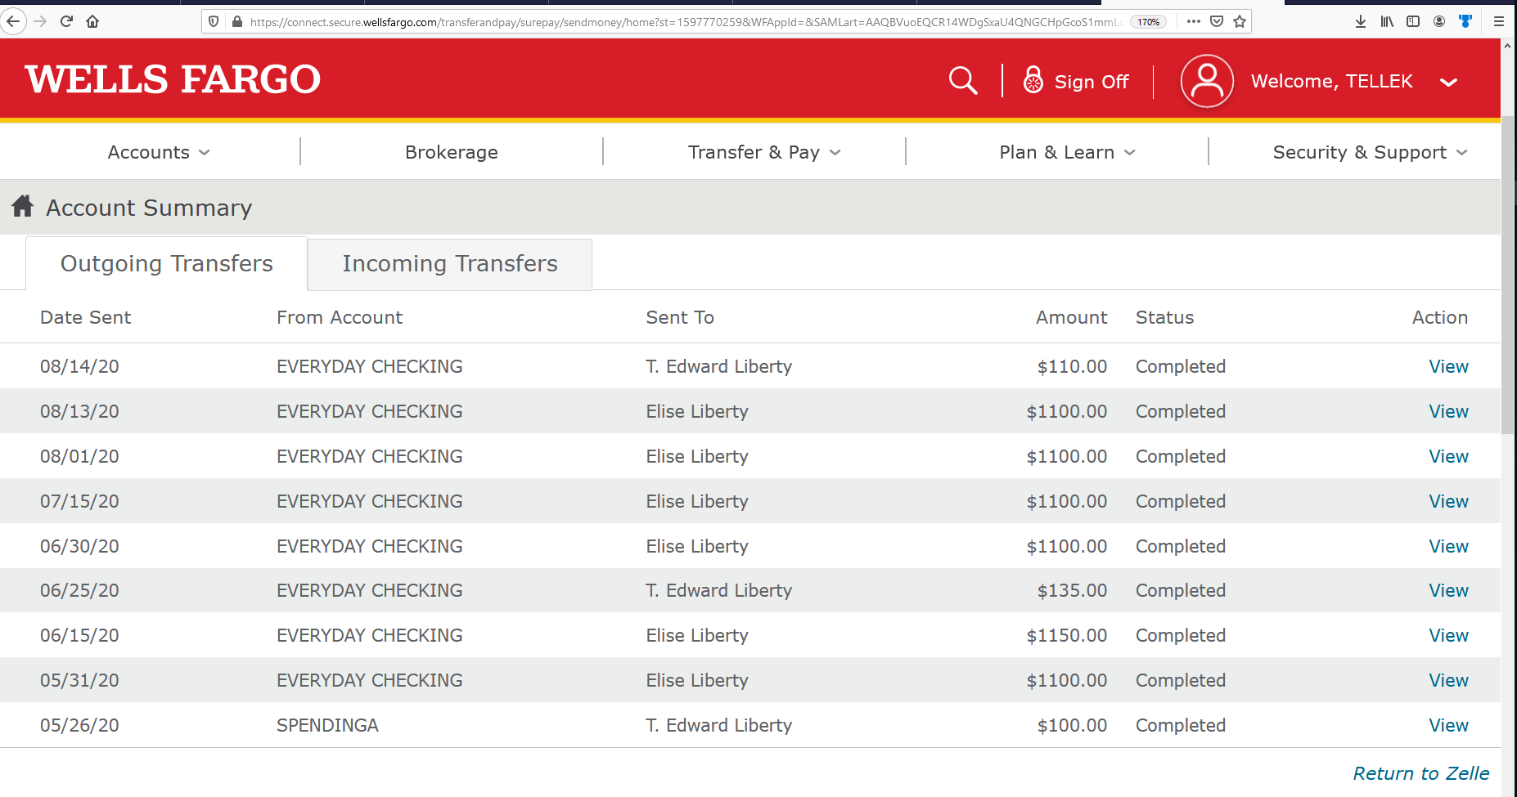

See screenshot of my paystub below. My pay have not always been 80/HR. There were times it was less. What do we do in that case? Angelique has never accepted the fact that my child support should change even if I made less money. However, I can’t see my kids.

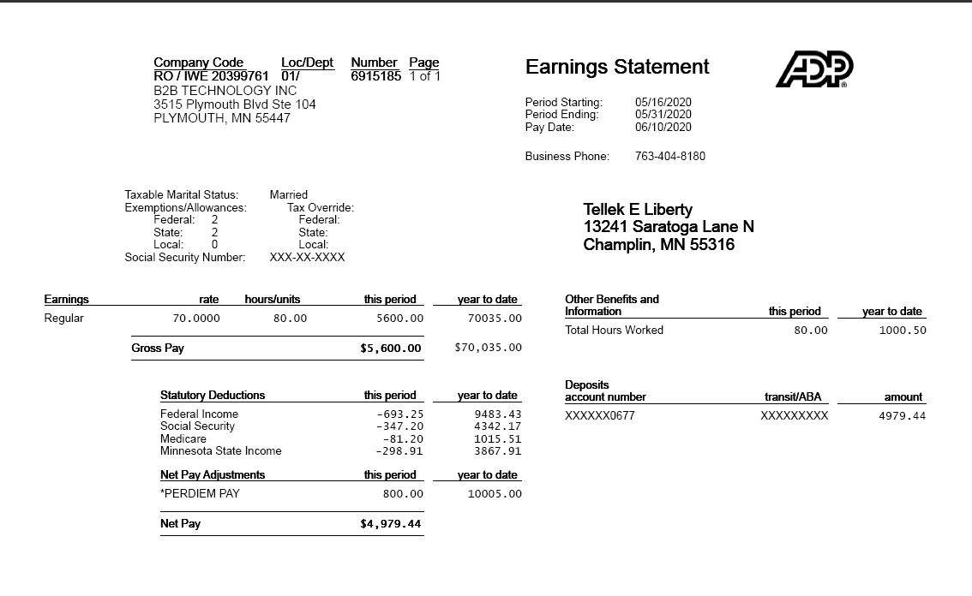

15. I am essential worker and is not in the position to travel out of Maryland during the

current pandemic. I am asking the court to deny Tellek’s request to amend the child

support and custody arrangements based to the facts that I have outlined above.